**HW1: Oracle SQL Language Fundamentals I**

**I2I ACADEMY TRAİNİNG DOCUMENT**

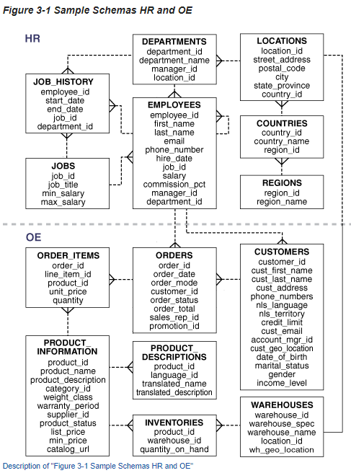

**Bağlantı Adresi=** <https://docs.oracle.com/database/121/COMSC/diagrams.htm#COMSC00016>

# Oracle SQL Language Fundamentals I

## Exercise SQL01-EX-01:

**Definiton :** Write an SQL query that selects employee’s id, employee’s first name and employee’s department name for all employees. (Please use HR.EMPLOYEES and HR.DEPARTMENTS tables.)

**Objectives** : To learn relations on tables and SQL language keyword JOIN.

tablo içeren bir resim

Açıklama otomatik olarak oluşturuldu**Exercise Keywords:** INNER JOIN, JOIN.

**SOLUTİON:**

**1)** Select e.employee_id , e.first_name , d.department_name from HR.EMPLOYEES e join HR.DEPARTMENTS d on e.department_id=d.department_id;

**2)** Select e.employee_id , e.first_name , .department_name

from HR.EMPLOYEES e inner join HR.DEPARTMENTS d on e.department_id=d.department_id;

**3)** Select e.employee_id , e.first_name , .department_name

from HR.EMPLOYEES e , HR.DEPARTMENTS d where e.department_id=d.department_id;

## Exercise SQL01-EX-02:

**Definiton :** Create a report that displays the employee’s id and their manager’s id. (Please use HR.EMPLOYEES table)

**Objectives** : To learn SQL join logic like SELF JOIN.

**SOLUTION:** Select employee_id , manager_id from HR.EMPLOYEES where manager_id is not null

**NOTE:** we use “is not null” phrase because of manager_id has “null” values

## Exercise SQL01-EX-03:

tablo içeren bir resim

Açıklama otomatik olarak oluşturuldu**Definiton :** For example; first three character of PHONE_NUMBER column gives us a operator of employee. Create a report that displays the operators and their total subscriber. But we want two different displays with diffrent queries. (Please use HR.EMPLOYEES table)

**Objectives** : To learn basic SQL keywords like COUNT, SUM, CASE.

**SOLUTION:** select substr(phone_number,1,3) as Operator ,count(*) as Total from HR.EMPLOYEES Group by substr(phone_number,1,3);

## Exercise SQL01-EX-04:

**Definiton :** Create a table (table name like HR.EMP) from HR.EMPLOYEES table. Insert a new row to HR.EMP table and update this employee’s phone number and salary. Delete your new row and display the HR.EMP table. Finally drop your table HR.EMP.

**Objectives** : To learn basic SQL keywords like INSERT, UPDATE, DELETE, DROP and CREATE TABLE from table.

**SOLUTION: CREATE TABLE** HR.EMP AS(SELECT * FROM HR.employees);

**insert into** HR.EMP (EMPLOYEE_ID,FIRST_NAME,LAST_NAME,EMAIL,PHONE_NUMBER,HIRE_DATE,JOB_ID,SALARY,COMMISSION_PCT,MANAGER_ID,DEPARTMENT_ID)

**VALUES** (155,'cihan','kement','hotmail','590.111.2222',to_date('27/09/2022','DD/MM/YYYY'),'IT_PROG',35000,0.4,103,60);

**UPDATE** HR.EMP **SET** PHONE_NUMBER = '555.555.5555',SALARY=39000 **WHERE** EMPLOYEE_ID=155;

**SELECT** * **FROM** HR.EMP;

**DELETE FROM** HR.EMP WHERE EMPLOYEE_ID=155;

**DROP TABLE** HR.EMP

## Exercise SQL01-EX-05:

**Definiton :**

Select employees’ first name and last name as masked with “*” character as shown in sample output below.

**Objectives** : To learn basic SQL functions like length, substr, instr, trim, initcap, rpad, lpad, regexp_replace, regexp_substr

**SOLUTION: select** rpad(substr(first_name,1,2),length(first_name),'*') || ' '

|| rpad(substr(last_name,1,2),length(last_name),'*') as CUSTOMERNAME from HR.EMPLOYEES;